Contents
Tools 2
List of Keystroke/Utility Macros and Their Ribbon Buttons 2
How to “Install” or make these tools available? 5
How to “Install” the Sole Source Letter Template 8
Where’s the Developer Tab? 10
The PowerShell script Install 12
Notes on Code 13
Version 6 — What’s Been Added. 13
Scratch Sheet for Adding AutoText to Oft-Used Contact Management AutoText 14

Tools
Template Name: CM Utilities v65.dotm
Template/Add-In Path: C:\Documents and Settings\[YOUR LOGIN]\Application Data\Microsoft\Word\STARTUP\CM Utilities v65.dotm

List of Keystroke/Utility Macros and Their Ribbon Buttons
Ribbon Buttons | Keystroke | What it does | Macro Name  (To see the code  Press Alt-F11 to open up the VBA Editor) | Module/Class Module
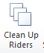 | - Alt C, R | Code updated to be much cleaner and to accommodate both the new 2016 Riders and still support the old Riders. Note: Still needs to be tested on K12.  - Deletes all the highlighted paragraphs with the names of riders and the fields, invisible to the naked eye, at the end of these paragraphs  - Also formats the rider's title so it automatically falls on the next page.  - Deletes the highlighted paragraph with the name of the active rider. Same as the 1st bullet  - And UNLINKS the field of the active rider. THIS is IMPORTANT because any changes made in the rider will be lost upon a field update, which can also happen when a document is printed out---if "Update Fields" on print is set. Of course pressing "F9" will totally wipe out any changes you've made if the rider is STILL a field.  - Modified June 7, 2016 to automatically switch on Redlining.  - Modified April 4, 2017 to now clean up K12 contracts as well.  K12 Contracts include removing the tables surrounding riders in order to allow more freedom in formatting (paragraphs in rider can be moved easily to the next page).  - Modified April 5, 2017 to remove the text: “MyRoad” from the rider as per Dale’s request. | Clean_Up_Riders  CleanUpRiders:  Method of Class clsCBRiders | modCBContractTools_v2  clsCBRiders
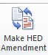 | - Alt-M, A | Creates an amendment | MakeAmendment  CreateAmendmentFromMain  Method of Class clsContract | modCBContractTools_v2  clsContract
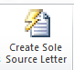 | - Alt-S,L | Sole Source Letter  Revision 01/31/2018 Updated AutoText for K12 (SSL-K12)  Revision 5/5/2017 Changed the hardcoded Sole Source Letter path from: C:\Users\ajones\AppData\Roaming\Microsoft\Templates\CM Current Templates\ to using Environment variable function: Environ$(USR_APPDATA) to retrieve specific user path. Also added new directory: Contracts Management as a template directory for any custom templates.  Revision 1/27/2017:  Added to this code library because CB shutdown macros in templates, but seemingly, not in Add-Ins  Sole Source template still needs to be distributed. | CreateSoleSourceLetter | modSoleSourceMain
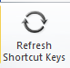 | - Alt-R,K | This macro adds the Keybindings maintained in this add-in to a user’s Normal Template so they may activate the macros with the shortcut keys listed in the 2nd column. | RefreshShortcuts | modCBContractTools_v2
 | - Alt-$ | Formats a set of numbers as a price  For example 4756 becomes $4,756.00 or if $4756 becomes $4,756.00  You have to select the whole number or select the whole table cell IF there is only 1 number in that cell.  Revision July 28, 2016: | FormatPrice | modCommonTools
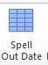 | - Alt-F,D | Converts any selected date and time if that is included too to “mmmm dd, yyyy format  For example: 6/29/1964 converted to June 29, 1964  You have to select the entire date.  Revision July 20, 2016: format changed from “mmmm dd, yyyy” to "mmmm d, yyyy" to fix 09/1/2016, for example being converted to “September 1, 2016” instead of “September 01, 2016” | FormatDateSpellOutMonth | modCommonTools
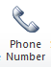 | - Alt-F,P | Converts a series of 10 digits to (###)-###-#### a phone number format  You only have to place the cursor in the number being converted (usually because there are no spaces in between the numbers) | FormatPhoneNumber | modCommonTools
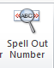 | - Alt-S,N | Converts selected numbers into text  Converts a number like 1,234,567 into One Million Two Hundred Thirty Four Thousand Five Hundred Sixty Seven or 543,678, 689 to Try yourself. You have to select the entire number  It cannot do decimals  Code used was borrowed from another source and slightly modified. Not my original code. | InterfaceForSpellNumber | modCommonTools
Not Implemented on Ribbon/Menus | - Alt-F,T | Formats the Client Information Table in Higher Ed agreements on page 5 | FormatClientInfoTable | modCommonTools
Not Implemented on Ribbon/Menus | - Alt D, D | DD or Dee, Dee ;-)  Removes the start and end date columns from fee schedule table in Higher Ed contracts.  Date Created: November 7 - 8, 2016 | RemoveTermDatesFromFeeSchedule | modCommonTools
Not Implemented on Ribbon/Menus | - Alt-R,T | Remove Tables Formatted Around Rider  Only in K12 contracts are the riders encased in several tables (one table inside of another table, inside of another table).  Comment: My assumption is the designer for the template was not comfortable with margins and Word Sections (though I don’t think sections are even needed as the margins are the same for the entire table)  Important Comment: If a shortcut key doesn’t work with a macro, you may have to remove/export the module and reinsert it.  I moved code from 1 module to another and it started working. Go figure. | RemoveSurroundingTables | modCBContractTools_v2
Not Implemented on Ribbon/Menus | - Alt-F,L | Allows you just to enter the date and have it formatted to: [DAY/DATE st,nd,rd, th] day of [MONTH], [YEAR] based on what you enter into the Input box | RunInputAmendmentDate | modCommonTools
Not Implemented on Ribbon/Menus | - Alt-S,S | Strips the space leading some sentences in cells for some reason. | StripSpace
Not Implemented on Ribbon/Menus | - Alt-D,S | Date format of [DAY/DATE st,nd,rd, th] day of [MONTH], [YEAR]  Note: This is similar to Alt-F,L | FormatDateDayOfMonthYear | modCommonTools
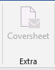 | - Alt-C, S | Creates coversheet for wet signature.

List of AutoText Used to Edit Higher Education Agreements
AutoText Name | 3 (or more) Letter Name activated with F3 | Description | Stored in Template
HSA - HED Standard Addendum | HSA | Helps easily create addendums | CB Utilities v2.dotm
HGH - HED Guidelines Hyperlink | HGH | Replaces the home link found in every rider | CB Utilities v2.dotm

HGH
http://media.collegeboard.com/digitalServices/pdf/research/guidelines-on-uses-of-college-board-test-scores-and-data.pdf and http://media.collegeboard.com/digitalServices/pdf/research/RDGuideforReleaseData.pdf

How to “Install” or make these tools available?
The CM Utilities Add-In/Template is stored on SharePoint at this link or paste https://mysharepoint/sdp/oosvp/RAS/Contracts Management into your browser
- Choose CM Utilities vX and select in the drop-down menu Send To, Download a Copy
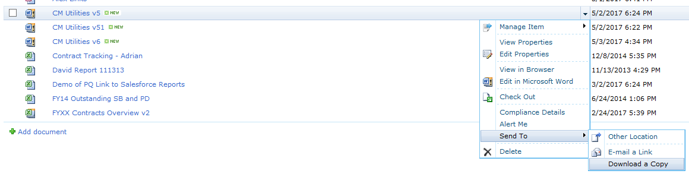
- After selecting Download a Copy the browser pop up below will display at the bottom of the browser.
- Select the Save drop-down and select Save As.
- Once you select Save As, you will be presented with an Explorer dialog box open to wherever you last save a file. Make sure the path at the top reads:
C:\Users\[YOUR LOGON NAME]\AppData\Roaming\Microsoft\Word\STARTUP\
Save the file there. Note: if you don’t have the Contracts Management directory, go ahead and create it. Lastly, restart Word.
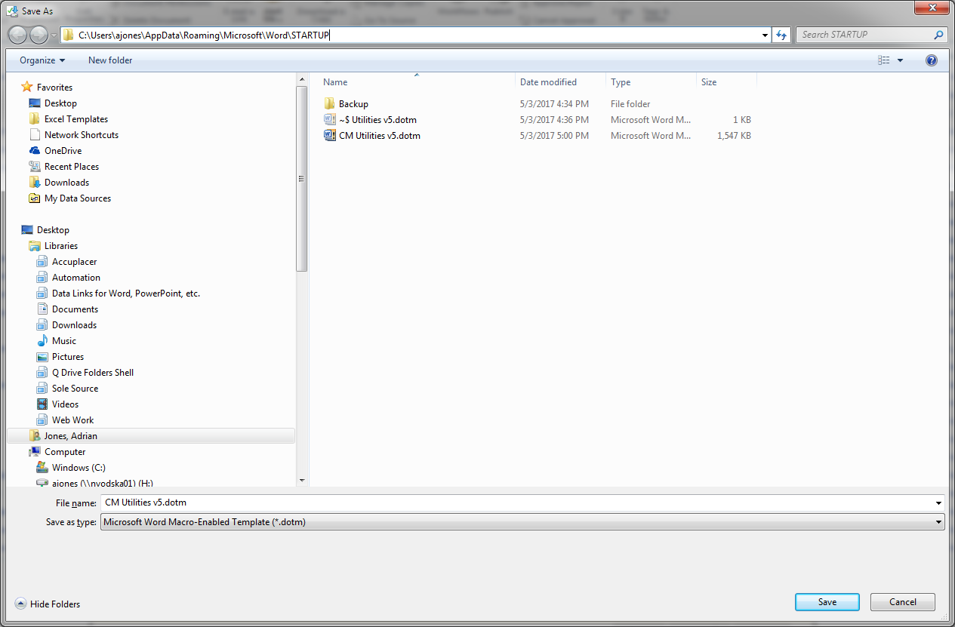
Open Word (Close Word, if it was open and Open it up again) and you should see the new tab called Contract Mgmt Utilities
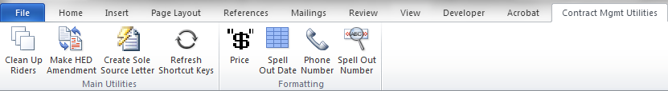
If the Contract Mgmt Utilties tab does not show up, check to see if the Add-In/Template is loaded by going to the Developer tab select Add-Ins in the Add-Ins group 2nd from the left on the Ribbon menu and see the dialog box seen below. Make sure CM Utilites is checked
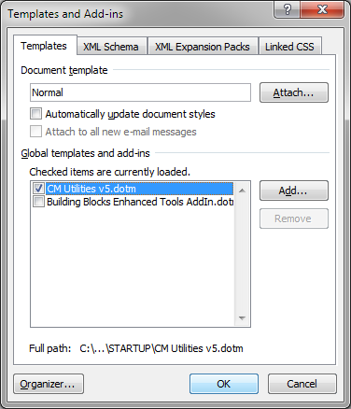

How to “Install” the Sole Source Letter Template
The Sole Source Letter Template is stored on SharePoint at this link or paste https://mysharepoint/sdp/oosvp/RAS/Contracts Management into your browser
- Choose Sole Source Letter v2 and select in the drop-down menu Send To, Download a Copy
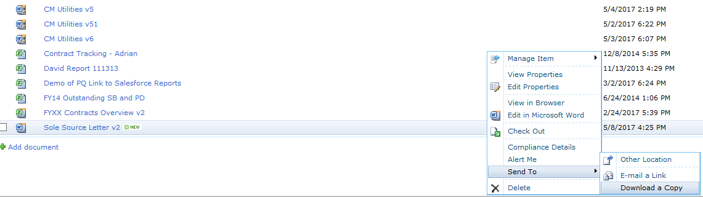
- After selecting Download a Copy the browser pop up below will display at the bottom of the browser.
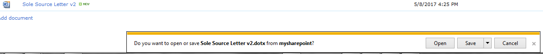
- Select the Save drop-down and select Save As.
- Once you select Save As, you will be presented with an Explorer dialog box open to wherever you last save a file. Make sure the path at the top reads:
C:\Users\[YOUR LOGON NAME]\AppData\Roaming\Microsoft\Templates\Contracts Management\
Save the file there. Note: if you don’t have the Contracts Management directory, go ahead and create it.
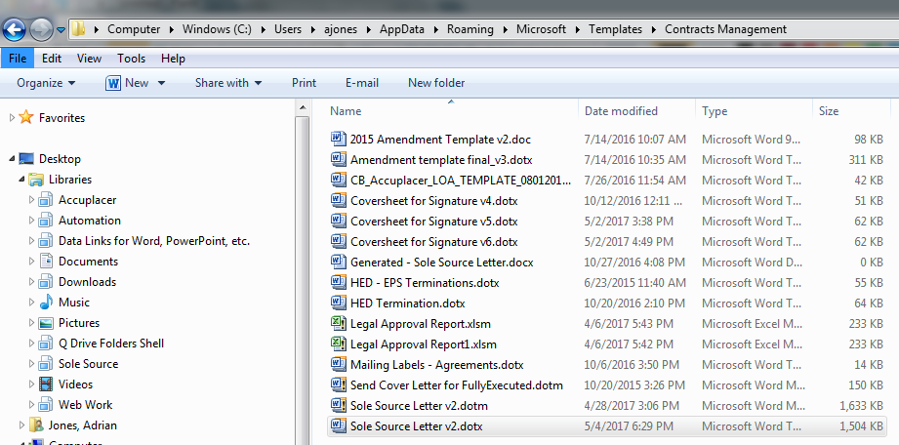

Where’s the Developer Tab?
The Developer Tab doesn’t always show. The default is for it to be hidden as it is an advanced option and most users never need it.
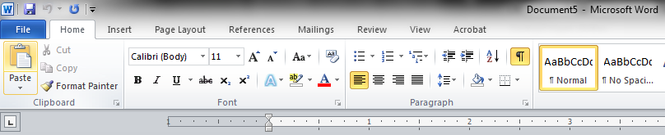
However, you need it to look like this
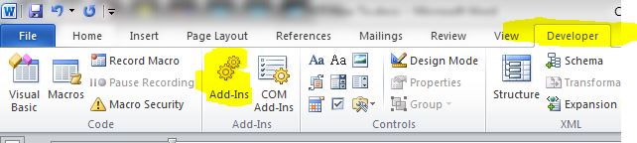
If you cannot see the Developer Tab, right-click on the menu/Ribbon and select Customize the Ribbon
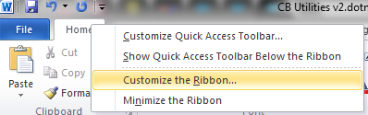
In the list box on the right where you see Main Tabs and check Developer
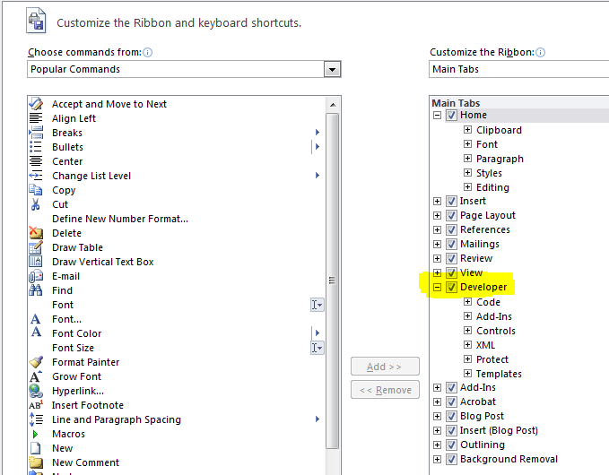

The PowerShell script Install
Note: In order for the steps below to work a PowerShell command window must be opened up and this command must be run at the command line:
Set-ExecutionPolicy -ExecutionPolicy Unrestricted. This command allows you to run PowerShell scripts
After the script has been run, the same command must be run at the command line BUT with Restricted typed in instead of Unrestricted
Set-ExecutionPolicy -ExecutionPolicy Restricted. This command BLOCKS PowerShell scripts, as it should be
Right-Click on the Install-CBUtilities.ps1 file and select Run with PowerShell | When the PowerShell script is running
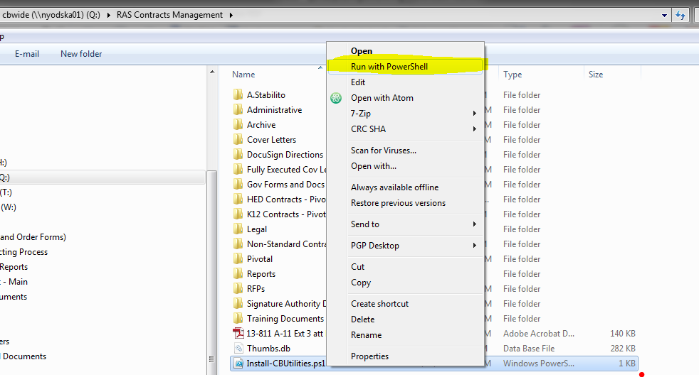 | 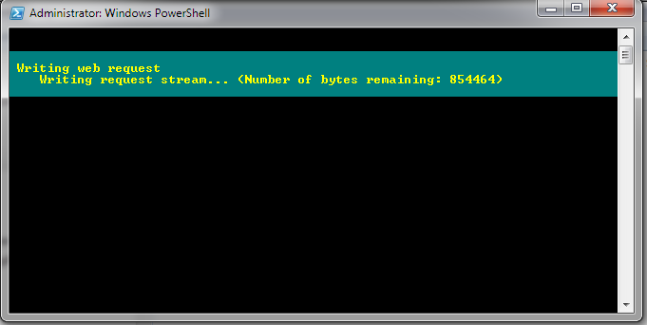

After running the script check to see if it has been saved to the Startup Directory:
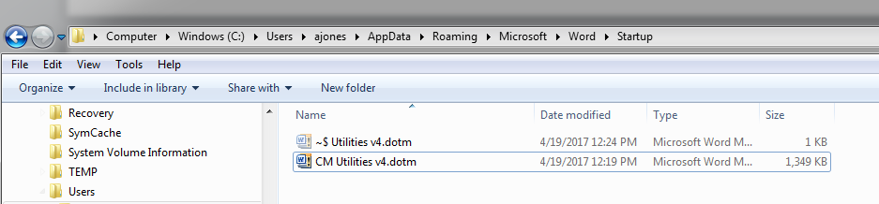

Notes on Code
Notes on “Rider Fields”
The riders in our agreement templates are If fields. They sit in a single paragraph, have text highlighted and begin with “-“, end with a “:” and the field starts after that.

Version 6 — What’s Been Added.
- Buttons grey out when they should not be run in certain contexts. For example no need to run clean up riders when there is no document open or when the add-in itself is open.
- Ability to create a Higher Ed. Amendment from the generated contract.

Version 6.5 — What’s Been Added.
- Replacing the correct links in each Rider only does the last rider if there are 2. Now it does as many incorrect links as there are.
- Coversheet functionality added.

Scratch Sheet for Adding AutoText to Oft-Used Contact Management AutoText
AutoText Name | Text | Notes
Not Sub recipient | If the Client is using federal funds to pay for all or a portion of the Services and Deliverables furnished by the College Board under this Agreement, Client acknowledges and agrees that the College Board shall not be categorized as a “subrecipient” receiving a federal award as defined by OMB Circular Subpart A.210(c) of Circular No. A-133. The College Board shall be defined as a “vendor” that provides good and services within normal business operations, provides similar goods or services to other purchasers and operates in a competitive environment. Client acknowledges and agrees that the substance of the relationship with the College Board is that of a vendor not a subrecipient. | I have been working with Finance and the AP program to address an issue that arises when certain public entities (mostly, state departments of education) incorrectly categorize the College Board as a subrecipient of a federal grant award.  This subjects us to auditing and other fiscal requirements that we cannot and should not adhere to. Finance and AP have approved the following language that I would like included in the College Readiness Agreement and our AP Letter Agreement.  Could you please include this in the current version of our agreements? Please add this language as the second paragraph under the Relationship of the Parties section 9.6 of the CRS.

Possible location on the network/SharePoint for CB_Utilies_AutoText Word file
- https://mysharepoint/sdp/oosvp/RAS/Contracts Management/CM-transfer/Contracts Management/Contracts Data
- https://mysharepoint/sdp/oosvp/RAS/Contracts Management/CM-transfer/Contracts Management/Contracts Templates

For Testing Small sections of code on items in document
The Fee Schedule in our HED Contracts:
ATTACHMENT 2 TO COLLEGE BOARD ENROLLMENT AGREEMENT
FEES SCHEDULE

Product Name | Start Date |  | End Date | Quantity | Total Cost
Student Search Service (R) - Subscription | 9/1/2019 |  | 8/31/2020 | 70000 | $ 30100.00
Student Search Service (R) - Subscription | 9/1/2017 |  | 8/31/2018 | 70000 | $ 30100.00
Student Search Service (R) - Subscription | 9/1/2018 |  | 8/31/2019 | 70000 | $ 30100.00
Enrollment Planning Service (TM) - Unlimited Subscription | 9/1/2017 |  | 8/31/2018 | 1 | $ 7560.00
 |  | Total Price: |  | $97860.00

$ 30100.00
$ 30100.00
$ 30100.00
$ 7560.00
$ 7560.00
$ 7560.00
$ 7560.00
$97860.00
$97860.00
$97860.00
$97860.00
$ 7560.00
$ 7560.00
$ 7560.00
$ 7560.00

2128670451
9/16/2016
06/29/1964
6/17/1985
08/22/1969

On the Insert tab, the galleries include items that are designed to coordinate with the overall look of your document. You can use these galleries to insert tables, headers, footers, lists, cover pages, and other document 2128670451 building blocks. When you $ 97860.00 pictures, charts, or diagrams, they also coordinate with your $ 7560.00 document look.
You can easily change the formatting of selected text in the document text by choosing a look for the selected text from the Quick Styles gallery on the Home tab. You can also format text directly by using the other controls on the Home tab. Most controls offer a $ 9,7860.00 of using the look from the current theme or using a format that you specify directly.
To change the overall look of your $ 30100.00, choose new Theme elements on the Page Layout tab. To change the looks available in the Quick Style gallery, use the Change Current Quick Style Set command. Both the Themes gallery and the Quick Styles gallery provide reset commands so that you can always restore the look of your document to the original contained in your current template.

AutoText Creation Area

Testing Two Weeks from today
[14 DAYS FROM CURRENT DATE]

